HWK 7:

I pledge on my honor that I have not given or received any unauthorized assistance on this

assignment/examination. I further pledge that I have not copied any material from a book, article,

the Internet or any other source except where I have expressly cited the source.

Signature: Kanika Yadav

Date: 10/20/2022

Topic name -

Name - Kanika Yadav

Date: October 20, 2022

W&A Chapter - 7

Question No – Q36, Q54 & Q 70

Page no – 406, 415, 417 respectively

**Management Overview**

**Q. 36**

**Problem Statement:**

W&A Ch 7 4E#36 (equally, 3E#36) **Portfolio optimization**.

Add a new stock, stock 4, to the model in Example 7.9. Assume that the estimated mean and standard deviation of return for stock 4 are 0.125 and 0.175, respectively. Also, assume the correlations between stock 4 and the original three stocks are 0.3, 0.5, and 0.8. Run Solver on the modified model, where the required expected portfolio return is again 0.12. Is stock in the optimal portfolio? Then run SolverTable as in the example. Is stock 4 in any of the optimal portfolios on the efficient frontier?

**Data Sources:**      The same question as in the context book and consider the problem for the given data - see P07_36.xlsx under modules.

**Model Approach:** Nonlinear Optimization using GRG Nonlinear method

**Solution & Sensitivity Analysis:**

As per the result,

The objective function with variable input as investment decisions for all the four stocks is derived to be optimal in fractions of -

As it is observed Fraction for **Stock 1** is the highest with **0.4987** following with the fraction for **Stock 4** as second highest of **0.4021**. Stock 3 must have a smaller portion **of 0.0992** and Stock 2 if not purchased will be the most beneficial option. The company should put fractions of upto as given in the solution for Stock 1 Stock 3 & Stock 4 but it should not invest in stock 2 at all.  
This shows that there is limited constraint on total investment. As mentioned, the expected Portfolio return is of around 13%.   
Even when Stock 1 is risky due to the correlation effect it must be giving more returns as compared to other stocks.

The portfolio variance is of around 0.0208 which is showing the standard deviation of 0.1441 which can be probabilistic in nature. Given that we are asked for upto 13% of returns that means a lot of risk and if it is less than that there could be negative returns.

If we check the sensitivity analysis graph for the percentage of expected portfolio return the convex graph looks to be returning the highest solution at 14% i.e., Portfolio variance of 0.04 and standard deviation of 0.16. This shows there is more possibility of greater solution than the constraint applied.   
Rather there is also a drawback that can be observed on selecting return above 14% there could be a steep difference in the portfolio variance which will lead to lowest standard deviation and performance. That won’t change and will continue to show 0% results. Since it is a convex result the

**Conclusion:**

**Is stock in the optimal portfolio?**

The constraints for this model are linear, and it can be shown that the portfolio variance is a convex function of the investment fractions. Therefore, the Solver solution is guaranteed to be optimal.

**Is stock 4 in any of the optimal portfolios on the efficient frontier?**

As mentioned in above sensitivity analysis report Stock 4 seems to be at optimal portfolio when the constrain of 13% of risk is applied. That is around 0.4 of the stock 4 fraction to be invested for better returns.

**Q. 54 Problem Statement:** Optimal production with products that are substitutes for each other.

- see P07_54.xlsx under modules.  
A company manufactures two products. If it charges price p for product i, it can sell q units of product i, ii where, q1 = 60-3p1 +p2 and q2 = 80+2p2 -p1.   
It costs $5 to produce a unit of product 1 and $12 to produce a unit of product 2. How many units of each product should the company produce, and what prices should it charge, to maximize its profit?

**Data Sources:** As given in P0_54 excel file - P07_54.xlsx 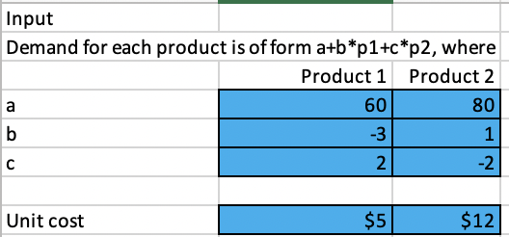

**Model Approach:** Nonlinear Optimization using GRG Nonlinear method

**Solution & Sensitivity Analysis:**

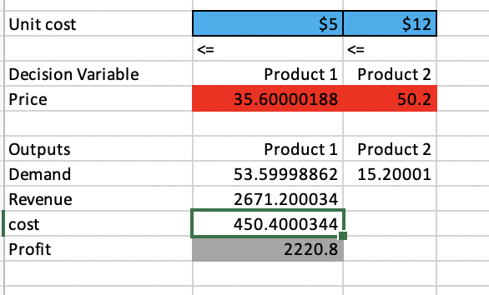

**How many units of each product should the company produce, and what prices should it charge, to maximize its profit?**

As found in the example execution using the GRG Linear method to solve the given problem based on the constraints defined, The Products should have minimum units of 60 and 80 respectively for Product 1 and Product 2 whereas the unit cost should be charged at - $35.6 for Product 1 and $50.2 for Product 2 to be produced as an optimal solution.   
It is also observed that the combine cost of the Products produced is 450.4 whereas the profit acquired out of the result is of - **$2220.8** that is the best optimal solution for the products with their maximum profits.

**Q. 70 Problem Statement:** Each morning during rush hour, 10,000 people want  
to travel from New Jersey to New York City. If a person takes the commuter train, the trip lasts  
40 minutes. If x thousand people per morning drive to New York, it takes 20 + 5x minutes to make the trip. This problem illustrates a basic fact of life: If people make their decisions individually, they will cause more congestion than is actually necessary.

1. Show that if people make their decisions individually, an average of 4000 people will travel by road from New Jersey to New York. Here you should assume that people will divide up between the trains and roads in a way that makes the average travel time by road equal to the travel time by train. When this “equilibrium” occurs, nobody has an incentive to switch from the road to the train or vice versa.

2. Show that the average travel time per person is minimized if 2000 people travel by road

**Data Sources: -** As given in the Problem statement above - P07_70.xlsx under modules.

**Model Approach:** We use the GRG Non linear Method to find the optimal solution using the solver table, where we have used Forward derivative and the population size of 100 and Require Bounds on variables are tick marked.

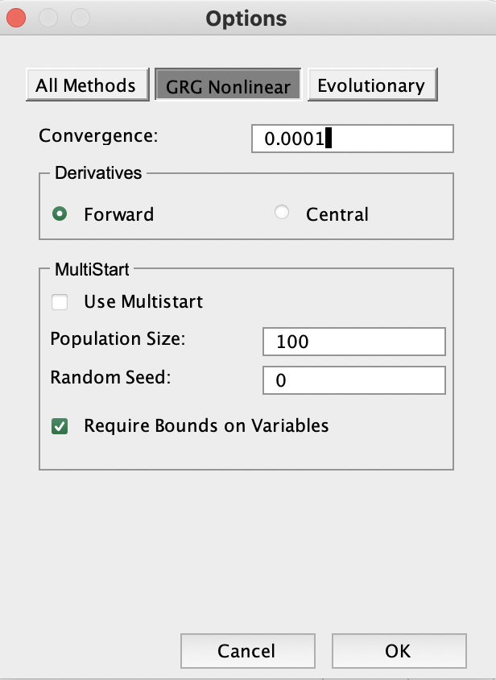

**Solution:**1. If people make their decisions individually, an average of 4000 people will travel by road from New Jersey to New York and we have assumed that people will divide up between the trains and roads by car which creates a constraint that makes the average travel time by road equal to the travel time by train. Now the optimal travel time by road will be 40 min which can be seen the same as the commuter will spend in commuting by Train which is also 40 as the initial input that we entered. Hence it is clear that the average travel time by road equals the travel time by train.

2. Show that the average travel time per person is minimized if 2000 people travel by road.

Now when we add a constraint that if 2000 mentioned as in B11, people travel by road the average travel time per person ,the travel time by road is 30 mins and the average time per person can be calculated as 38 mins.

Here we set objective as the average timer per person and changing variable as number of people and the decision variable as 2000 people travelling by road, the GRG non linear optimal solution provides us wit average time of 38 mins per person.

